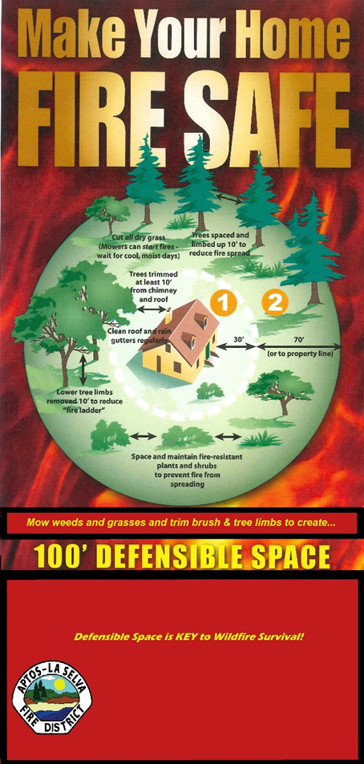
GOT DEFENSIBLE SPACE?
- Determine Risk: We want to help you identify the items that may be posing an unnecessary risk to your family and your property. Some risk factors can be influenced by:
- Aspect - Direction in which the face of the slope is situated;
- Slope - Most predominant angle of the hillside measured in % of slope, on the site that the structure is located on; and
- Vegetation or easily ignitable fuel types - within 0 to 100 feet of a structure.

- Do Your Part! Take responsibility for maintaining your property by:
- Trimming weeds and grasses to 4”-6” in height;
- Remove slash and debris from the base of your trees;
- Prune trees to within 6’-8’ of the ground;
- Remove dead and dying plants and vegetation;
- Recycle waste through disposal and chipping.

- Plant Spacing and Separation: Regardless of plant selection, shrubs should be spaced so that no continuity exists between the ground fuels and tree crowns. Separate tree crowns by at least 10 feet. Separate individual shrub crowns by at least two times the height or clump shrubs into islands. Separate the islands by a distance of no less than two times the canopy height.

- Creating Defensible Space does not mean removing all vegetation from around your home. Defensible Space is an area where material capable of allowing a fire to spread unchecked has been treated, cleared or modified to slow the rate and intensity of advancing wildfire and create an area for fire suppression operations to occur.
Aptos/La Selva Fire Protection District
6934 Soquel Drive Aptos, CA 95003
www.aptosfire.com

Creating Defensible Space
Takes COMMUNITY Effort!

Defensible Space Zones - Two zones make up the required 100 feet of Defensible Space:
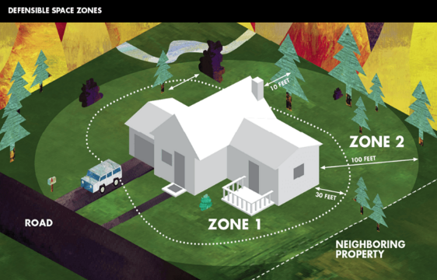
Zone 1 - 30 feet of Lean, Clean & Green
Zone 1 extends 30 feet* out from buildings, structures, decks, etc.
- Remove all dead plants, grass and weeds (vegetation).
- Remove dead or dry leaves and pine needles from your yard, roof and rain gutters.
- Trim trees regularly to keep branches a minimum of 10 feet from other trees.
- Remove branches that hang over your roof and keep dead branches 10 feet away from your chimney.
- Relocate wood piles into Zone 2.
- Remove or prune flammable plants and shrubs near windows.
- Remove vegetation and items that could catch fire from around and under decks.
- Create a separation between trees, shrubs and items that could catch fire, such as patio furniture, wood piles, swing sets, etc.

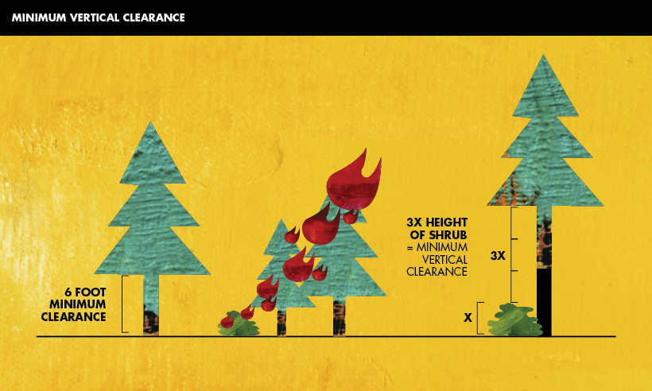
Zone 2 – 30-100 feet of Reduced Fuel
Zone 2 extends 100 feet out from buildings, structures, decks, etc.
- Cut or mow annual grass down to a maximum height of 4 inches.
- Create horizontal spacing between shrubs and trees. (See diagram)
- Create vertical spacing between grass, shrubs and trees. (See diagram)
- Remove fallen leaves, needles, twigs, bark, cones, and small branches. However, they may be permitted to a depth of 3 inches.
- Check with your local fire department for any additional defensible space or weed abatement ordinances.
Plant and Tree Spacing: The spacing between grass, shrubs, and trees is crucial to reduce the spread of wildfires. Spacing needed is determined by the type and size of brush and trees, as well as the slope of the land. For example, a property on a steep slope with larger vegetation requires greater spacing between trees and shrubs than a level property that has small, sparse vegetation.
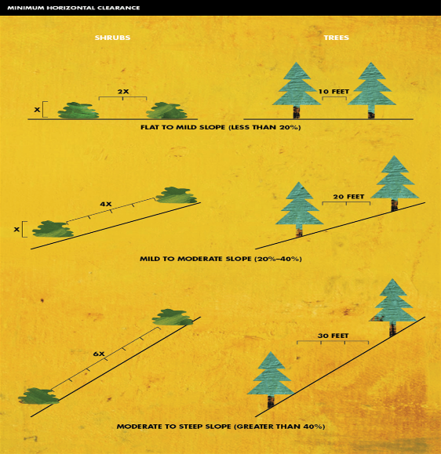
Vertical Spacing: Remove all tree branches at least 6 feet from the ground. Allow extra vertical space between shrubs and trees. Lack of vertical space can allow a fire to move from the ground to the brush to the tree tops like a ladder. To determine the proper vertical spacing between shrubs and the lowest branches of trees, use the formula below.
Example: A five foot shrub is growing near a tree. 3×5 = 15 feet of clearance needed between the top of the shrub and the lowest tree branch.
Horizontal Spacing
Horizontal spacing depends on the slope of the land and the height of the shrubs or trees. Check the chart (right) to determine spacing distance.
Fire-Safe Landscaping
Fire-safe landscaping isn’t necessarily the same thing as a well-maintained yard. Fire-safe landscaping uses fire-resistant plants that are strategically planted to resist the spread of fire to your home.
Choose Fire-Resistant Plants and Materials
- Create fire-safe zones with stone walls, patios, decks and roadways.
- Use rock, mulch, flower beds and gardens as ground cover for bare spaces and as effective firebreaks.
- There are no “fire-proof” plants. Select high-moisture plants that grow close to the ground and have a low sap or resin content.
- Check your local nursery, landscape contractor or nursery for advice on fire-resistant plants that are suited for your area.
ldfire a 2,000 structures are destroyed by a wildfire each year in California. Don’t let your home become a statistic – help us save you, your home and your community! Note: inspectors do not enter private property without owner permission. Hazards identified during inspections will be confined to those easily visible from the street.

